Taking a Break from Study: Your Guide to Intermission
What is Intermission?
Intermission is a supportive action that provides a temporary break from your studies, lasting up to two years. You might need to apply for intermission due to health reasons, personal reasons, or other factors that suggest taking a break might be beneficial.
After taking a break, you will return at the beginning of the semester/block of study that you left. Since this will be in a new academic year, this is likely to be with a new group of students.
For example, if you last attended in April of semester 2 before going on intermission, you would return at the beginning of semester 2 in the next academic year. There may therefore be an overlap of repeated study, with financial consequences.
Considerations During Intermission:
- Apply for intermission as soon as possible and ideally before you stop attending your course to avoid having to pay money back to the Student Loan company.
- Assessments that will be due during your intermission period will be automatically rearranged for when you return to study. If an assessment is due before your last date of attendance (before intermission) and you are unable to submit, you will need to submit a claim for Mitigating Circumstances. Usually however, students either intermit or claim mitigating circumstances.
- Periods of intermission may sometimes have conditions applied, but these will be discussed with you by your Academic Programme and/or the Student Engagement Team.
- If you are a degree apprentice, both your academic programme and your employer need to approve the intermission request.
- There are potential financial implications resulting from intermission (see below).
Financial Implications:
Late applications may result in financial liability based on last recorded attendance at a timetabled session. Please make sure your last date of attendance aligns with your intermission application date. Academic Registry will verify this with your programme.
If you apply mid-academic year, fees will follow university policy. (Check the Student Tuition & Accommodation Fees Policy section 7 for details.)
If you have received a maintenance loan payment and then intermitted, you may be expected to pay some or all of this money back to the Student Loan company, depending on your last date of attendance. The Student Loan company may agree to set up a payment plan, but repayments would be due immediately and not dependent on your income.
If you are in university accommodation, you are required to give 4 weeks’ written notice prior to leaving. You will need to pay rent for 4 weeks following your written communication to the Accommodation Team (accomodation@chi.ac.uk) to inform them that you are leaving. It is therefore advisable to give notice as soon as possible if you are planning to intermit. If you have already paid an instalment a refund will be calculated by the accommodation team.
Contact studentmoney@chi.ac.uk for further advice on financial impacts.
How to Proceed with Intermission:
Consult your loan provider (such as Student Finance England) regarding any funding implications. It is advised that you discuss your intermission with them prior to submitting your intermission form.
Discuss the situation with your Academic Adviser or Programme Coordinator before applying.
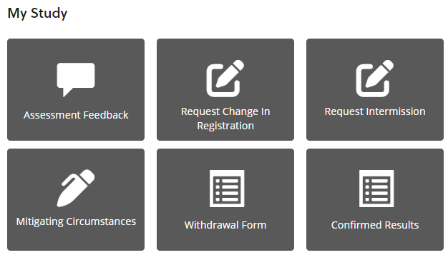
Submit your intermission request via the online form on ChiView, in the ‘My Study’ section on ‘My Student Page’. Student Records will then seek the necessary approval on your behalf and advise you of the outcome. Until your intermission has been formally processed, examination boards will assume you are a continuing student.

We advise you to reach out to studentengagement@chi.ac.uk to support you through the process of intermission. Other support services may also be helpful; you can email wellbeing@chi.ac.uk for advice and guidance.
See the Academic Regulations and Student Handbook for more information on Intermission.
Intermitting as an International Student
If you intermit or withdraw from your studies, or if we withdraw your sponsorship, the Home Office will curtail (shorten) your visa. You must provide the University with your flight departure details.
Normally, if you have more than 60 days left on your visa, your visa will be reduced to 60 days. If you have less than 60 days left, UKVI may leave it as it is. You should expect to receive “a notice of cancellation” email from UKVI to the email address you used when you first applied for your visa. This email will confirm your visa cancellation and confirms your new end date. Your visa is usually curtailed within 60 days of the date of the email. You should avoid becoming an overstayer and leave the UK, apply for a new Student Route visa or switch to a different visa category (whichever is applicable in your circumstances) as soon as possible. If you leave the UK after the new visa expiry date, it will affect any future visa applications you make to the UK.
Please note that you will need a new Student Route visa to return to the UK. You should get in touch with the International Advice team for immigration advice before intermitting and when you plan to return from your period of intermission. For more information, please look at the Chichester International Advice Moodle page or email international@chi.ac.uk

Returning from Intermission:
You will be invited to re-register for return to study shortly before your intermission is due to end. Should your plans have changed, for any reason, please contact the Student Records Team (sturecords@chi.ac.uk).
Extension to Intermission:
In certain circumstances you may be unable or not ready to return from intermission. Extensions may be granted providing it would not lead to intermission totalling more than two years during a course. In such cases you may be advised to withdraw and re-apply when you feel able/ready to return to either part-time or full-time study. Should you wish to discuss extending your intermission, please contact the Student Records Team (sturecords@chi.ac.uk).
FAQS
Am I a failure if I intermit?
Absolutely not. Intermission is a supportive action used to make sure you are able to study the best you can, you may need a break for many reasons.
How long can I intermit?
Up to 2 years per course, subject to programme approval.
Will I be able to finish my degree if my course has stopped?
You would have to discuss this with your programme.
Will I have access to Moodle/academic resources or be able to submit assessments?
No, the purpose of an intermission is to give you a break from study. As mentioned earlier, you can look at academic resources and submit assessments upon your return.
Can I access wellbeing support during my intermission?
Email studentengagement@chi.ac.uk for advice and guidance whilst you are on intermission.
How will my maintenance loan be affected?
Your funding entitlement will be recalculated to ensure you are not paid for any time you have not been attending. Any money classed as an overpayment will need to be paid back. A payment plan can be set up, but these payments will be expected immediately and will not be dependent on your income.
Please speak with studentmoney@chi.ac.uk for more advice specific to your situation.
Is there a deadline for intermission?
Intermission requests should be submitted at the earliest opportunity to avoid negative financial implications. Retrospective intermissions will not usually be approved.
What support is available for international students considering intermission?
If you are an international student, as well as the support offered to all students, our International Team will be happy to offer advice more specific to your situation. For more advice, please look at the Chichester International Advice Moodle page or email international@chi.ac.uk.

