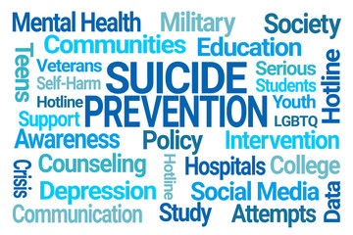

If you feel yourself or someone you know is unable to keep safe from suicide or self-harm, please call 999 or go to your local A&E department
(BOC – St. Richards Hospital PO19 6SE
BRC – Bognor Regis Memorial Hospital PO22 9PP)

 | Websites  - Preventing Suicide in Sussex – practical and bullet point advice for those experiencing or supporting those with suicidal thoughts.  - Staying safe from suicidal thoughts – resources to help you create a safety plan to keep yourself safe in a crisis.  - Confidential emotional support line – immediate support for those currently experiencing suicidal thoughts.  - Samaritans – immediate support for those who are suicidal and advice on how to reach out and support someone with suicidal thoughts and self-harm.  - Mind – general information about suicide and how to get support.
 | Factsheets  - Suicidal thoughts: how to cope (Rethink Mental Illness) - a factsheet with practical advice for those experiencing suicidal thoughts, with information on how to stay safe and access support.  - Suicidal thoughts: how to support someone (Rethink Mental Illness) – a factsheet explaining why someone might experience suicidal thoughts and how you can support them and yourself.
 | Printable Workbooks & Guides  - My Safety Plan – a downloadable or online safety plan template (visit https://stayingsafe.net/home for guidance on how to fill it out).  - Coping with suicidal thoughts (1) – practical techniques and advice for how to cope with suicidal thoughts.  - Coping with suicidal thoughts (2) – guidance on understanding your suicidal thoughts and practical advice on reducing thoughts of suicide. Includes blank safety plan to fill out.
 | Free Online Courses  - Gateway Training – a 5-to-10-minute introduction to suicide awareness you will learn how to approach and advise someone who may be considering taking their own life.  - In-depth suicide awareness training – gain the skills and confidence to help someone who may be considering suicide and gain an understanding of the importance of breaking the stigma around suicide by encouraging open conversations about it.  - Understanding suicide and suicide prevention strategies in a global context – for anyone who would like to learn more about the risk factors, stigma, and impact of suicide on a societal level, as well as ways to help prevent it.
 | Books on Prescription  - Suicide Prevention. 2014  Justin Healey  Electronic version available in library  - How to help the suicidal person choose life. 2017  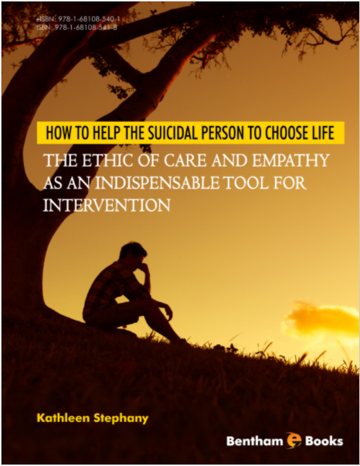  Kathleen Stephany  Electronic version available in library
 |   Free Apps    - Samaritans Self-help – allows the user to track their mood and create safety plans, as well as providing techniques to help cope with difficult feelings.    - Stay Safe – a pocket suicide prevention resource which includes a safety plan with customisable reasons to live and information for those experiencing or supporting someone with suicidal thoughts.  - distrACT – easy, quick, and discreet access to information and advice about suicide and self-harm.    - Combined Minds – support and practical advice for those experiencing or supporting someone through a mental health condition.
 | Helplines  - Samaritans 116 123  24/7  - Hopeline UK (Papyrus) 0800 068 4141  9am to 12pm Daily  - CALM 0800 58 58 58  5pm to 12pm Daily  - Mind Infoline 0300 123 3393  9am – 6pm Mon – Fri (except bank holidays)  - No Panic Helpline 0300 772 9844  10am – 10pm daily  - Youth Helpline (13-20yrs) 0330 606 1174  M,Tu,W,F 3pm – 6pm, Th 3pm -8am, Sa 6pm – 8pm
 | Text Support  - Text “SHOUT” to 85258 for crisis support 24/7  - Text 07860 039967 to speak with a suicide prevention advisor 9am to 12pm Daily
 | Email Support  - Jo@samritans.org  Response within 24 hours  - Pat@papyrus-uk.org  - info@mind.org.uk
 | Audios  - Mental Health Foundation Podcast, by Mental Health Foundation  - Healing from Depression, by Douglas Bloch
 | Student Support & Wellbeing  - ASK Wellbeing – drop-in to speak to a wellbeing advisor for general wellbeing advice and signposting to services that can support you.  - Coping and living mindfully (CALM) – an introduction to DBT skills to lean how to regulate emotions and cope with distressing feelings.
 | Local Services  - Contact your local GP/Doctor (it is possible to book a GP appointment on behalf of someone else, so long as they are registered with that GP and are willing to attend the appointment)  Find a local GP here https://www.nhs.uk/service-search/find-a-GP  - West Sussex IAPT service - Time to Talk  Refer online at www.sussexcommunity.nhs.uk or call 01273 265967

