Health and Wellbeing advice and information for students

Please keep this leaflet in case you need to refer to it.
Look After Your Health
Whilst at the University of Chichester we support and encourage students to look after their health and wellbeing. This booklet aims to help inform you of the resources available and how best to access them.
The University Student Health Service
The Registered Nurse Health Advisers are approachable and willing to listen to any concerns in confidence. These may include issues such as:
- Health concerns and information on a variety of health issues
- Minor injuries and illness
- Self-care advice
- Concerns regarding friends, family or other students
- Academic issues relating to health and wellbeing
- Mitigating circumstances
- Healthy eating / eating disorders
- Drug, alcohol support and smoking cessation
- Self-harm
- Sexual Health / condoms / chlamydia screening
- Sexuality and gender
- Pregnancy (planned or unplanned) including undertaking a risk assessment
- Pregnancy loss
- Sexual Assault, issues around consent and healthy relationships
- Sign-posting to other Professionals, within and external to the University
Please contact student health if you have pre-existing health problems that may require support or first aid intervention whilst at University, for example epilepsy or diabetes. This enables us to provide support tailored to your individual needs and academic requirements
You can contact the University Nurse Health Advisers:
Email: studenthealth@chi.ac.uk
Telephone: 01243 816111 – mobile 07739 983703
http://help.chi.ac.uk/student-health-service

Immunisations
The University recommends all students are up to date on all vaccinations. Please check with your GP surgery prior to starting. Please ensure you have your Meningitis ACWY vaccination and Covid vaccination.
Registering with a Doctor (GP)
We recommend that all students register with a GP local to the University Campus. It will still be possible for you to see your ‘home’ GP during holidays as a temporary patient.
As an exception, if you awaiting referral to specialist services via your home GP, for instance for an eating disorder or autism assessment, please discuss this with your GP and student health before registering locally as this may prolong referral.

Why register with a local GP?
If you are not registered with a local doctor, you will have difficulty getting an appointment and crucial time could be wasted in an emergency.
Register now so you can access:
- 24-hour emergency cover and/or home visits
- routine appointments for ongoing medical problems or acute illness
- repeat prescriptions
- doctor's certificates or notes required by your university course
- contraceptive services and advice
- holiday vaccinations and health advice
The University Nurse Health Advisers are happy to assist you to register with a doctor as soon as possible after arriving at the University. You will need your local Bognor or Chichester address.
The University has an agreement with 3 local surgeries for students to register with the NHS or students can choose a surgery more convenient to their residence. You can register online so there is no need to attend in person.
Lavant Rd Surgery for students living on or near the Bishop Otter Campus (north of the market cross).
Lavant Road Surgery
8 Lavant Road
Chichester PO19 5RH
01243 527264 www.lavantsurgery.co.uk
Lavant Road student new patient registration
Google maps link or see page 19 for a map.
The Cathedral Medical Group, Cawley Road, for students living off campus in accommodation at Stockbridge Road Halls and Fishbourne Halls (south of the Market cross).
Cathedral Medical Group
Cawley Road,
Chichester, PO19 1XT
01243 813450 www.cathedralmedicalgroup.co.uk
Cathedral Medical Group registration form (pdf)
Cathedral Medical Group registration form (doc)
Google maps link or see page 18 for a map.

Maywood Healthcare Centre for students living at Bognor Regis Campus.
Maywood Healthcare Centre
225 Hawthorn Rd,
Bognor Regis
PO21 2UW
01243 829141 www.maywoodsurgery.com
Maywood Surgery for university students
Google maps link or see page 20 for a map.

General Practitioner out of hours service
If you need to see a GP out of surgery hours contact NHS 111 service and speak to an operator who will advise you (Dial 111).

How do you make an appointment?
Same day appointments are usually made by telephoning the surgery early in the morning. You need to check with your chosen surgery as different systems are in operation. It is usually possible to pre-book appointments for up to 2 weeks in advance, however fewer of these appointments are available.
NHS services fees
Patients usually have to contribute towards NHS costs with prescription fees for medications, dental fees and optician’s fees. You may be able to claim exemption if you have a low income, see the NHS webpage:
NHS prescription charges - NHS (www.nhs.uk)
Getting medical care as a student - NHS (www.nhs.uk)
Getting the most from your Pharmacist
Pharmacists provide a range of services including fulfilling prescriptions, giving advice on how to treat and recognise minor illnesses and sexual health and contraceptive advice; this could save you a trip to the GP. The pharmacist should be able to tell you if you need to see your GP. If you need to talk in confidence ask the pharmacist if there is somewhere private where you can talk.
The pharmacy sells some medication over the counter, without a prescription. The contents and action of the medicine will be the same as the prescribed medicine but it may be cheaper. Ask your GP if the medicine that has been prescribed for you is available over the counter or ask the pharmacist when you hand your prescription to them. Most pharmacies offer the morning after pill for a charge, following a consultation with the pharmacist, some will provide the medication for free of charge (there may be age restrictions).

Medical Emergencies
Anyone who is involved in a medical emergency should Dial 999; ask for an ambulance and say where you are and what is wrong. The ambulance should take you to the nearest Accident and Emergency department. This service is free but should only be used for life threatening emergencies or when emergency treatment is needed immediately.
Mental Health Emergencies
If a person’s mental or emotional state deteriorates quickly and this places them or someone else at risk, this is often called a mental health crisis. In this situation it is important to get help quickly:
- Make an emergency appointment with your GP.
- Go to the Accident and Emergency department at St. Richards Hospital, Chichester.
- Out of Hours: Call the NHS Sussex Mental Health line: 0300 5000 101. This telephone line is open 24 hours a day 7 days a week.
If you feel someone is an immediate danger to themselves or others call for an ambulance and/or the police on 999.
If an ambulance is called on campus, please inform Security and the SIZ (Support and Information Zone) on 01243 81(6363) and they can direct the ambulance to the precise area to avoid delay.
Do not delay accessing urgent help straight away.
Accessing University Support
The Wellbeing team at the University is available for support weekdays term time only. There are drop in sessions you can attend or you can book an appointment by emailing wellbeing@chi.ac.uk. You can see the timetable and other services offered on their webpages: wellbeing.chi.ac.uk
If you need a First Aider or Security support you can call the university emergency number 01243 816363.
Accommodation 24/7 Phone Numbers
If you are in halls you can get out of hours support from the Accommodation team:
Chichester campus 01243 793477
Bognor Regis campus 01243 793488
Stockbridge 01243 533356 / 07824 349543
Fishbourne 01243 790279 / 07791 692966
Westgate 01243 812931 / 07795 257068
Villa Maria, Prince of Wales, Garth House 01243 793488
Millfield Close, Lewis Road, Spitalfield Lane 01243 703477
NHS 111 Service
When to use it
You should use the NHS 111 service if you urgently need medical help or advice but it's not a life-threatening situation.
Dial 111 if:
- you need medical help fast but it's not a 999 emergency
- you think you need to go to A&E or need another NHS urgent care service
- you don't know who to call or you don't have a GP to call
- it’s out of hours for your GP
- you need health information or reassurance about what to do next
There is also a free confidential interpreter service, which is available in many languages. Simply mention the language you wish to use when the NHS 111 operator answers your call.
The University Nurse Health Advisers or first aiders can provide support for minor injuries.
Dental Emergencies
If you have dental trauma and bleeding following an accident it is advisable that you go to the nearest Accident and Emergency unit at the local hospital.
Otherwise contact the Jubilee dental centre for urgent dental care:
Jubilee Dental Centre (booked appointment only),
St Richards Hospital, Chichester.
Open Monday to Friday 5.30pm- 10.00 pm.
Phone 01243 831790/793697 after 5.30 for same day appointment.
Saturday, Sunday, bank holidays 8.30 am - 1.00pm.
Dental Treatment
The University advises all students to remain with their NHS dentist at home and to have regular check-ups and treatment during holiday times. NHS dentists are extremely difficult to find, you will have to pay for a private dentist. To find a dentist go to https://www.nhs.uk/service-search/find-a-dentist or the NHS dental helpline is 0300 311 2233.
Sexual Health
If you have concerns about sexually transmitted infections or would like information you can contact the University Nurse Health Advisers or visit the Sexual Health Clinic at St Richards Hospital.
The Sexual Health Chichester clinic at St Richards offers a wide range of services where you can be seen for sexual health screening and contraception and specialist appointment sessions. You can also order online STI testing kits from this website:
https://www.sexualhealthwestsussex.nhs.uk/online-testing/
This specialist team are based at:
Chichester Sexual Health Clinic
St Richards Hospital
Chichester
PO19 6SE
Central Booking Line 01903 285199
Services offered
- Sexually transmitted infection screening and treatment
- Chlamydia testing and treatment (available to all)
- HIV testing and treatment
- Pregnancy testing
- Termination/abortion referrals
- Free condoms
- Emergency contraception
- General Contraception
- Psychosexual counselling – by appointment

Getting there
The clinic is situated on the 1st Floor of St Richards Hospital within the Outpatients Department and is signposted from the Outpatients Department entrance.
For clinic venues and opening times please visit their website: www.sexualhealthwestsussex.nhs.uk
The Esther Project offers information, advice, and confidential support around sexual health and contraception to students engaging in the sex industry with:
- Free condoms & lube
- Access to free Chlamydia tests
- Access to free HIV home self-test kits
- Free pregnancy tests
- Support to access specialist sexual health services
YADA: Sexual Health (esther-project.org)
Pregnancy Options Centre - 01243 784177
Pregnancy Options Centre provides free, non-directive help and support to women and men facing unplanned pregnancy or struggling following an abortion or pregnancy loss.
https://pregnancyoptionscentre.org.uk/
Support for Sexual Assault and Misconduct
If you have any concerns around sexual misconduct or consent, the University sexual violence and misconduct liaison officer can be contacted during working hours on 07739 983703 or studenthealth@chi.ac.uk.
You can download the Sexual Assault and Misconduct Policy, and the Procedure for Reporting and Investigating from here: https://www.chi.ac.uk/about-us/policies-and-statements/academic-and-student-support/
Our ‘Help and Support after Sexual Assault’ booklet can be downloaded here: https://help.chi.ac.uk/help-and-support-after-sexual-assault
The Sussex Police website is very helpful and informative: How to report rape, sexual assault or other sexual offences | Sussex Police
If you have been accused of sexual violence or misconduct our support booklet can be downloaded here: https://help.chi.ac.uk/guidance-students-accused-sexual-violence-or-misconduct
SARCs (sexual assault referral centres) are specialist medical and forensic services for anyone who has been raped or sexually assaulted. They have specialist staff to help you make informed decisions about what to do next.
Saturn Centre Sexual assault and referral centre 01293 600469
In an Emergency contact the Police on 999
University Student Support and Wellbeing Services
The University has a range of services available to support you during your time at Chichester.
Disability and Dyslexia Services
The Disability and Dyslexia Service offers support and advice to students with disabilities, continuing health conditions, mental health conditions and specific learning needs.
If you have a disability or health condition that affects your living accommodation or study requirements in any way please contact the disability team at the earliest possible opportunity.
Appointments with advisers in the team can be booked through the SIZ (Support and Information Zone) on 01243 816222.
You can find further information on the University web pages: https://www.chi.ac.uk/study-us/student-services/disability-dyslexia-and-medical-condition
Or by contacting the team direct by phone 01243 812076, or email: disability@chi.ac.uk
Student Money Team
Offer information, advice and guidance on all aspects of student finance and funding. They administer the University Support Fund and emergency loans facility. They also offer help with budgeting and money management.
Contact studentmoney@chi.ac.uk
Wellbeing Service
The Wellbeing team include mental health advisers, wellbeing advisers and student counselling. They offer daily drop-in sessions and online appointments; please see their website for more information: https://wellbeing.chi.ac.uk/
Mental Health Advisers
Offer confidential, expert advice and signposting for any students with diagnosed mental health conditions as well as those experiencing problems with low mood, anxiety or managing emotions.
Student Wellbeing Advisers
Offer a friendly advice and/or mentorship around a range of issues concerning student life such as academic worries, relationships or stress.
Student Counselling Service
A free confidential service offering students the opportunity to talk through transient personal problems with a qualified and registered counsellor.
To access services of the Wellbeing team, students should email wellbeing@chi.ac.uk

International Advice
International students may benefit from some additional support while studying in the UK. The International Student Advisers can provide help and support for all International students on a range of issues including, visas, immigration rules, funding options, home sickness/culture shock, academic and practical problems and more.
You can find our office location and drop-in hours on our Moodle pages.
Contact: 01243-812194 / 2192 /International@chi.ac.uk
Moodle: https://moodle.chi.ac.uk/course/view.php?id=86214#
Additional Information for International Students
https://beprepared.chi.ac.uk/register-with-a-gp/
To access health care in the UK, you need to register with a GP when you arrive. You will be supported with this as part of the International Orientation. Arriving in a new country is a very busy time for international students and there are a lot of changes to go through. In this type of situation, with all its stresses, you can find yourself paying less attention than usual to your health. Existing health problems can also be made worse by the effects of adjusting to unfamiliar food, a different climate and the emotional strains of being away from home.
The National Health Service (NHS) is the UK’s state healthcare system providing a wide range of health care services including appointments with a doctor, hospital treatment and dental care. If your course is 6 months or longer, you will have to pay the NHS Health surcharge as part of your Visa application, which will entitle you to free healthcare whilst you complete your studies. We advise that you still take our private medical insurance in addition to this as NHS treatment will not cover you for all eventualities, for example, if you get sick and want to be transported home or want to have a family member to stay in the UK to look after you, this will not be covered. Any treatment that you need to pay for will be charged at 150% of the national NHS rate.
Some EU students may be able to apply for a refund of the health surcharge once they arrive:
Students studying for more than 6 months - you may be eligible for a full or partial reimbursement if all of the following are true:
- you’re a full-time student in UK higher education
- your visa started on or after 1 January 2021
- you have an EHIC issued in an EU country or Switzerland (you MUST APPLY FOR THIS IN YOUR HOME COUNTRY prior to arrival in the UK)
- you do not work in the UK
For more information, see:
https://www.gov.uk/guidance/immigration-health-surcharge-for-eu-students-in-the-uk
Students studying for less than 6 months
If your stay in the UK is 6 months or less, you do not need to pay the immigration health surcharge. If you have a valid EU or Switzerland-issued EHIC or are a Norwegian citizen with a valid Norwegian passport, you can access medically necessary treatment during your stay.
If you’re a citizen of Iceland or Liechtenstein, you may have to pay for any NHS healthcare you receive.

Meningitis and septicaemia can kill in hours
Remember, vaccines can't prevent all strains of meningitis.
You're fit and healthy - you think it's only flu, a hangover or the effects of a heavy night out, but don't just leave it.
- Check out the symptoms
- If you're feeling really bad, tell someone
- If a mate's looking rough, stick around
- If it gets worse fast, get medical help immediately
Symptoms can appear in any order.
Someone who feels really ill needs medical help even if they have no rash or a rash that fades. Not everyone gets all these symptoms.
- Meningitis and septicaemia can be hard to recognise at first. Symptoms can appear in any order, but the first symptoms are usually fever, vomiting, headache and feeling unwell, just like many mild illnesses
- Symptoms which are more specific to meningitis and septicaemia and less common in milder illnesses are Limb pain and cold hands and feet. These often appear earlier than a rash, neck stiffness, photophobia and confusion.
- Not everyone gets all these symptoms
- Septicaemia can occur with or without meningitis
- In some cases of meningitis, a rash may not appear
See more at: http://www.meningitis.org/symptoms/young-people/#

Symptoms of meningitis and septicaemia
Fever and/or vomiting | Severe headache | Limb/joint/muscle pain (sometimes with pain/diarrhoea) | Pale or mottled skin
 | 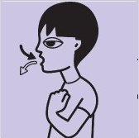
Cold hand and feet/shivering | Breathing fast/breathless | Rash (anywhere on the body) | Stiff neck (less common in young children)
Dislike of bright lights (less common in young children) | Very sleepy /vacant /difficult to wake | Confused /delirious | Seizures (fits) may also be seen

Be Alert for tiny red or brown pin prick marks which can change into purple blotches or blood blisters.

Tumbler test for septicaemia
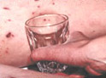
If a glass tumbler is pressed firmly against a septicaemia rash, the marks will not fade. You will be able to see the rash through the glass. If this happens get medical advice immediately. It is harder to see on dark skin, so check paler areas. Remember someone who is very ill needs medical help even if they have no rash or a rash that fades
Septicaemia rash on black skin
A septicaemia rash can be harder to see on dark skin, so check for spots over the whole body, especially on paler areas like palms of the hands, the soles of the feet, on the stomach, inside the eyelids (conjunctiva) and on the roof of the mouth (palate).
- 1 in 10 of us at any time carry the bacteria which cause these diseases and this is usually harmless
- We pass them on by close contact, such as kissing
- In a very few people the bacteria get into the blood stream and cause meningitis and/or septicaemia
- We don't know who is at risk - so get the symptoms sussed - you could save a life.
Meningitis - Symptoms - NHS (www.nhs.uk)

Contacts/useful Telephone Numbers:
Bognor Regis War Memorial Hospital 01243 865418
Cathedral Medical Group 01243 813450
www.cathedralmedicalgroup.co.uk
Chichester Sexual Health Clinic 01903 285199
www.sexualhealthwestsussex.nhs.uk
International Advice 01243 812194
Email: international@chi.ac.uk
Jubilee Dental Centre 01243 793697
Lavant Road Surgery, Chichester 01243 527264
www.lavantsurgery.co.uk
Life Centre 01243 786349
Charity supporting survivors of rape and sexual abuse info@lifecentre.uk.com
Maywood Healthcare Centre, Bognor Regis 01243 829141
www.maywoodsurgery.com
NHS 111 111
Pregnancy Options Centre 01243 784177
Saturn Centre - Sexual Assault and Referral Centre (SARC) 01293 600469
Student Money Team 01243 816038
Email: studentmoney@chi.ac.uk
Support and Information Zone 01243 816222
Email: help@chi.ac.uk (internal ext. 6222)
St. Richards Hospital, Chichester 01243 788122
Student Health Service 01243 816111
mobile (during office hours 9-5 semester time) 07739 983703
The Samaritans 116 123
University Disability and Dyslexia Service 01243 812076
Email: disability@chi.ac.uk
Wellbeing Service Website: www.wellbeing.ac.uk
Email: wellbeing@chi.ac.uk

Cathedral Medical Group
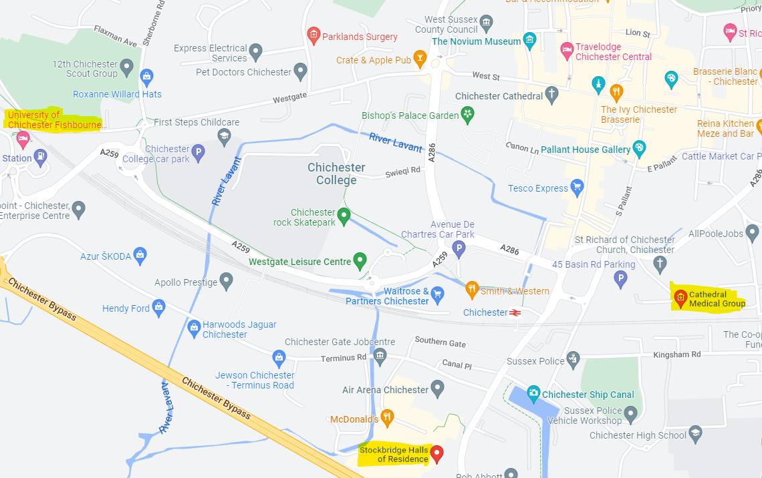
Cathedral Medical Group is about 10 minutes’ walk from Stockbridge Halls passing the bus station and down Market Avenue.
From Fishbourne halls the surgery is about a 30-minute walk or you can catch the U7 bus from the Tesco store to Avenue de Chartres Westgate and walk towards the bus station and down Market Avenue.
Lavant Road Doctors Surgery

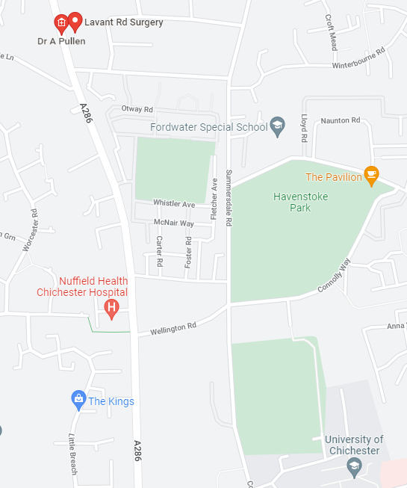

Lavant Road surgery is 10 to 15-minute walk from the Chichester campus. Turn right out of the main campus entrance and walk up the hill. Take the second turning on the left, Broadway. Walk to end of road past the one stop shop. Then turn right at the main road junction onto Lavant Road. The surgery is just on the right after about 50 metres.

Maywood Healthcare Centre, Bognor Regis - 01243 829141
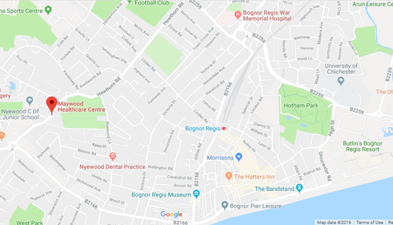
Check out the best ways to get the surgery here
To walk takes about half an hour (see above map)
Bus travel
Walk from the University to the Hotham Park bus stop (Butlins side) and get on the 600 bus service for Chichester and this will take you to the Hammonds roundabout and then simply walk to the surgery at 225 Hawthorn Road (5-minute walk).

If you would like to view this publication in another format (e.g. large print version) please request this by emailing StudentHealth@chi.ac.uk

(Updated August 2023)

