Inter-Library Loan: Electronic Delivery
You will receive the following email from the British Library when your requested document has been made available to access:
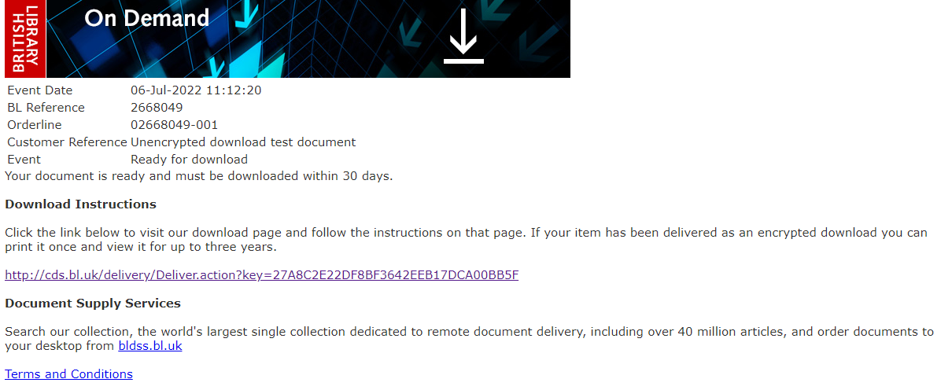
Click here
Click on the link to be taken to the document download screen:
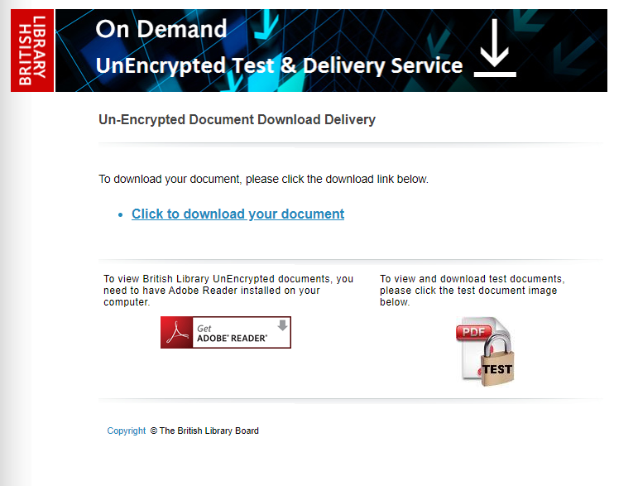
Click here
Click to download your document.
You can download and save the document onto your own device for up 30 days from receipt of the email. The document is yours to keep for your personal study. Please do not share or post online any document you receive from the British Library.

