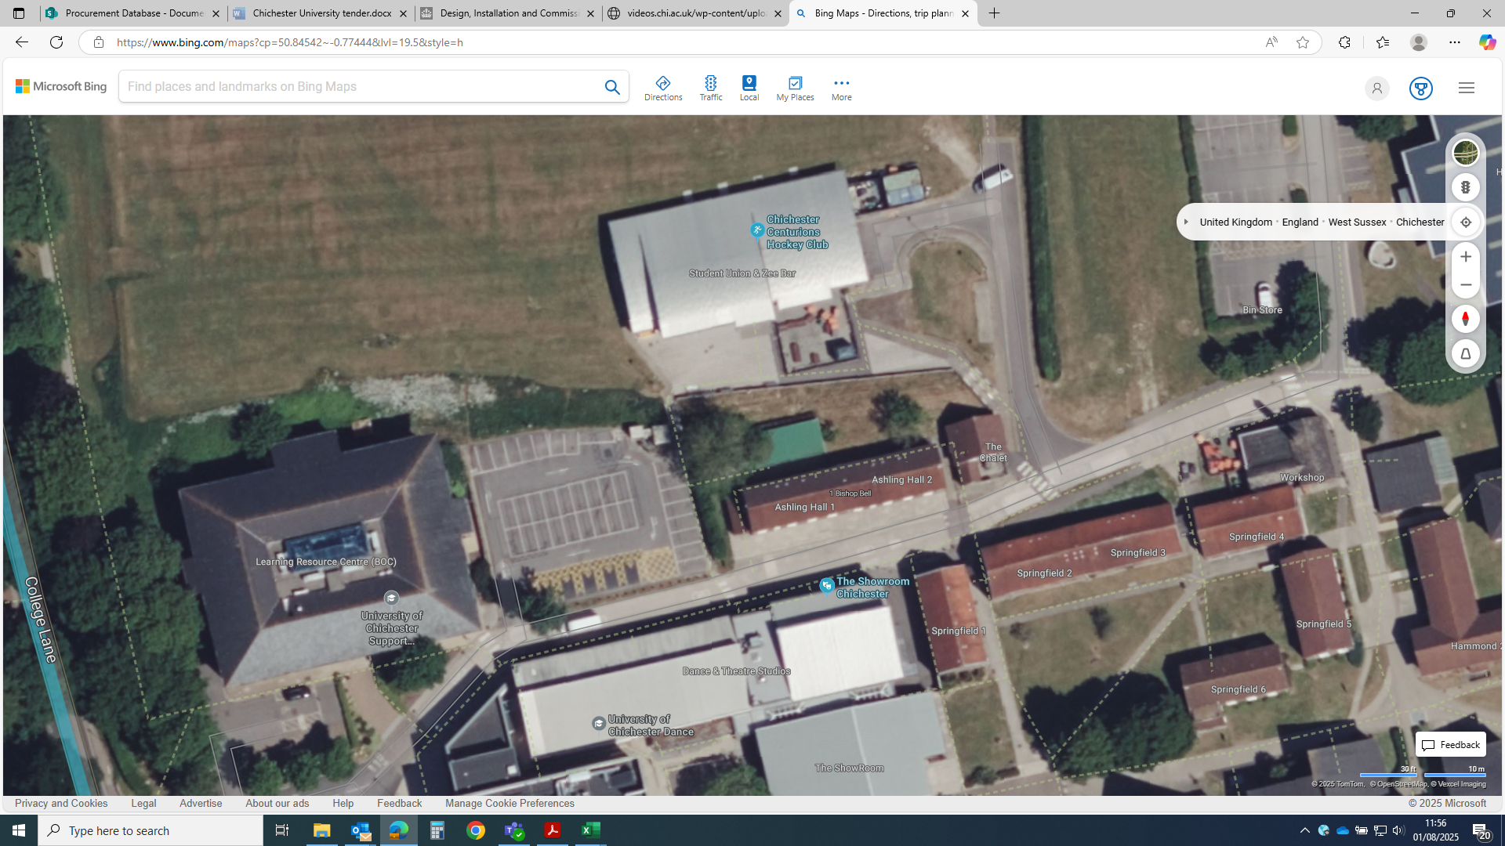
Bishop Otter Campus, LRC car park – 8x chargers serving parking spaces as marked
Source: https://www.bing.com/maps?cp=50.788219%7E-0.662561&lvl=18.7&style=h
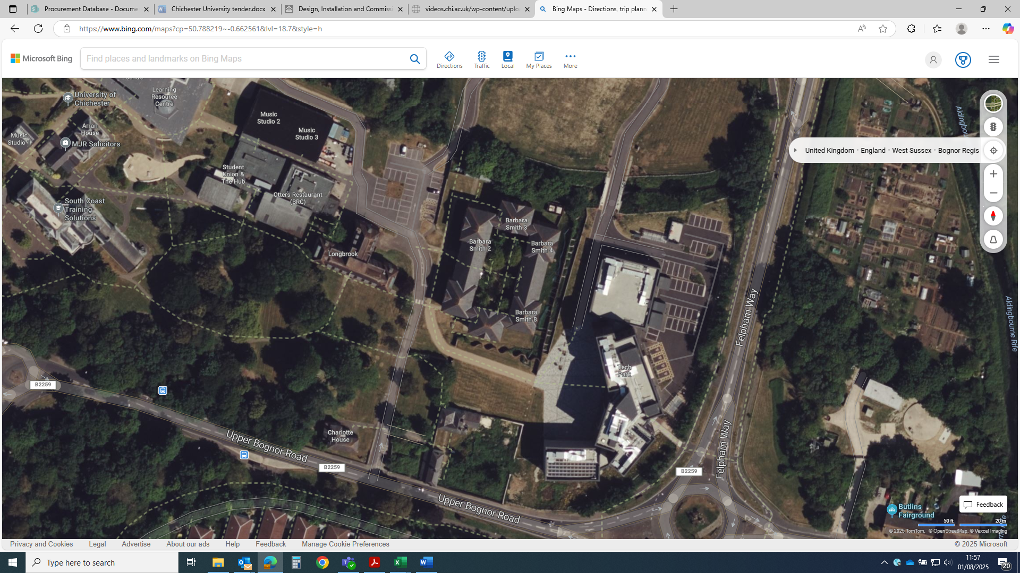
Bognor Regis Campus, adjacent to Barbara Smith Hall - 6x chargers serving parking spaces as marked
Source: https://www.bing.com/maps?cp=50.788219%7E-0.662561&lvl=18.7&style=h

