Amberley, Chilgrove and Harting PV
Tender clarification regarding site set-up:
Suppliers have asked what is the University anticipating in relation to site set-up and supporting facilities?
Answer:
Due to the constrained site immediately adjacent to the three blocks, the only site infrastructure expected to be immediately next to each is expected to be the access scaffolding. The scaffolding will initially incorporate chutes at designated skip positions for getting slates off the roof, but these are likely to have been removed by the time the PV contractor comes to site.
All other site infrastructure, such as storage and welfare facilities are expected to be sited in the main carpark to the north of the campus (circled below). As part of suppliers’ submissions, it will be helpful to understand what has been anticipated in relation to:
- Make-up (in terms of the facilities to be provided)
- Footprint (number of parking spaces required)
- Location (where is the preferred location and any constraints – driven possibly by services or servicing the set-up)
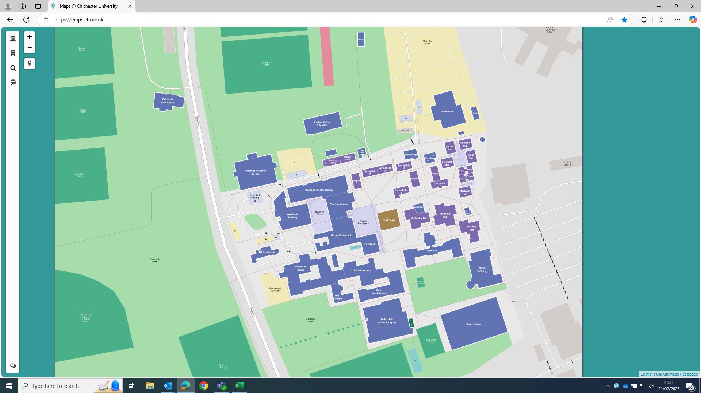

In relation to vehicle parking, suppliers should note their allocated site set-up should not include for vehicle parking. Contractors will be issued parking permits (for use in the main carpark) on a fair use basis. Vehicle sharing and other sustainable travel options should be supported wherever possible.

